 | 26.9.2 Editors - Properties Editor - Modifiers Properties Tab - Add Modifier menu - Normals modifiers
Table of content
Detailed table of content 1
Edit modifiers 3
Available content 3
Normal Edit 3
Weighted Normal 4
Smooth by Angle Modifier Asset 6

Detailed table of content
Detailed table of content
Detailed table of content 1
Edit modifiers 3
Available content 3
Mesh object 3
Normal Edit 3
Mode 3
Radial 3
Directional 3
Target 3
Parallel Normals 4
Mix 4
Mix Mode 4
Mix Factor 4
Vertex Group 4
Max Angle 4
Lock Polygon Normals 4
Offset 4
Weighted Normal 4
Weighting Mode 5
Face Area 5
Corner Angle 5
Face Area and Angle 5
Weight 5
Threshold 5
Keep Sharp 5
Face Influence 5
Vertex Group 6
Invert 6
Smooth by Angle Modifier Asset 6
Angle 6
Input Attribute Toggle 6
Ignore Sharpness 6
Manage 6
Bake 6
Bake Path 6
Named Attributes 6

Edit modifiers

Available content

Mesh object
- Normal Edit
- Weighted Normal
- Smooth by Angle Modifier Asset

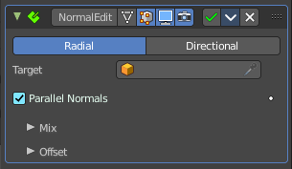
Normal Edit
The Normal Edit modifier affects (or generates) custom normals. It uses a few simple parametric methods to compute them, and mixes back those generated normals with existing ones.

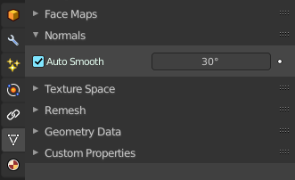
Note! This modifier requires custom normals to be enabled, which can be done by enabling Auto Smooth in the Properties.
Tip. More complex normal manipulations can be achieved by copying normals from one mesh to another, see the Data Transfer Modifier. Some shading effects can also make use of the Weighted Normals modifier.

Mode

Radial
Aligns normals with the (origin, vertex_coordinates) vector, in other words all normals seems to radiate from the given center point, as if they were emitted from an ellipsoid surface.

Directional
Makes all normals point (converge) towards a given target object.

Target
Uses this object’s origin as reference point when generating normals. A Target object is optional in Radial mode, but mandatory in Directional mode.

Parallel Normals
Only relevant in Directional mode. Makes all normals parallel to the line between both objects’ origins, instead of converging towards target’s origin.

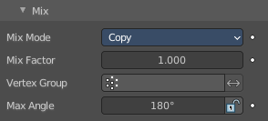
Mix

Mix Mode
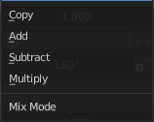
How to affect existing normals with newly generated ones.
Note that the Multiply option is not a cross product, but a mere component-by-component multiplication.

Mix Factor
How much of the generated normals get mixed into existing ones.

Vertex Group
Allows per-item fine control of the mix factor. The vertex group influence can be reverted by using the small “arrow” button to the right.

Max Angle
Forbids new generated normals to have an angle to the original normal above that given threshold. This is useful to prevent extreme changes, that can even lead to inverting the front/back sides of a face, and consequently to ugly shading artifacts.

Lock Polygon Normals
Prevents flipping (reversing front/back sides) of polygons which normal does not match anymore the side to which point its corners’ custom normals. Can also help avoiding shading issues.

Offset
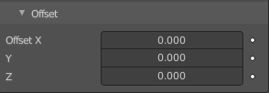
Gives the origin of the modified object an offset before using it to generate normals.
Offset is only relevant in Radial mode if no Target Object is set, and in Directional mode when Parallel Normals is set.

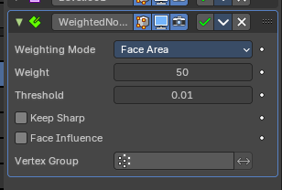
Weighted Normal
This modifier allows you to change the custom normals of a mesh. This can be useful to make some faces appear very flat during shading, among other effects.

Weighting Mode
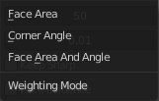
The normals around a vertex will be combined to create a custom (per face corner) normal using various weights for each. The Weighting Mode defines how to compute the weights.

Face Area
Weight according to the area of the face that the normal originates. A larger area means that the normal from that face will get a higher weight in final result.

Corner Angle
Weight according to the angle each face forms at the vertex.

Face Area and Angle
Weights are obtained by multiplying the face area and corner angle ones.

Weight
Determines how strongly the weights are biased according to the face areas and/or corner angles, a bit like a contrast setting for a picture.
A value of 50 means all faces are weighted uniformly.
More than 50 means faces with higher area or angles are given even more weight (more “contrast”).
Less than 50 means faces with higher area or angles are given lesser weights (less “contrast”).

Threshold
A weight-rounding threshold which means that, if two angles or areas differ by less than that threshold, they will get equal weights.

Keep Sharp
Preserve sharp edges, though smoothing will still happen if there are multiple faces between any two sharp edges.

Face Influence
Use face weights as assigned by the Set Strength tool or by the Set Strength mode of a Bevel modifier.
For example, if three faces meet at a vertex and have the face weights weak, medium, and strong, then only the normal associated with the strong face will be used to set the final result.

Vertex Group
If a vertex group is specified, the modifier will only affect those vertices.

Invert
Invert the selection (only affect the vertices not in the vertex group).

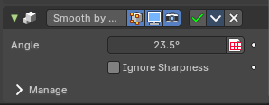
Smooth by Angle Modifier Asset
This modifier asset is a Geometry Nodegroup that does an “autosmooth” operation on the normals. By default this will consider edges that have been marked as sharp.

Angle
The autosmooth angle the smoothing will happen. Any face normal that is less than this amount will contain smooth normal angles.

Input Attribute Toggle
This can also be toggled to set by an attribute set by Geometry Nodes.

Ignore Sharpness
This will override the edges that have been marked sharp and smooth the neighboring face normals accordingly.

Manage
Advanced Geometry Nodegroup options.

Bake
Bake the information to a cache on disk.

Bake Path
The custom path this particular modifier asset will store the frames. You can define the path where these will bake per Geometry Nodes modifier. If not defined, it will default to the *.blend file location. To bake, you must save the file first.

Named Attributes
No named attributes are used with this modifier asset.

